

|  |  |
| --- | --- |
| **ASSIGNMENT** | |
| **Course Code** | 19CSC204A |
| **Course Name** | Logic Design |
| **Programme** | B. Tech |
| **Department** | Computer Science & Engineering |
| **Faculty** | Faculty of Engineering Technology |

#### 

|  |  |
| --- | --- |
| **Name of the Student** | SUBHENDU MAJI |
| **Reg. No** | 18ETCS002121 |
| **Semester/Year** | 3RD / 2019 |
| **Course Leader/s** | Mr. Narasimha Murthy K. R. and Mr. V. Deepak |

|  |  |  |  |  |  |  |  |  |
| --- | --- | --- | --- | --- | --- | --- | --- | --- |
| **Declaration Sheet** | | | | | | | | |
| Student Name | SUBHENDU MAJI | | | | | | | |
| Reg. No | 18ETCS002121 | | | | | | | |
| Programme | B. Tech | | | | | Semester/Year | 3rd / 2019 | |
| Course Code | 19CSC204A | | | | | | | |
| Course Title | Logic Design | | | | | | | |
| Course Date |  | | To | |  | | | |
| Course Leader | Mr. Narasimha Murthy K. R. and Mr. V. Deepak | | | | | | | |
| **Declaration**  The assignment submitted herewith is a result of my own investigations and that I have conformed to the guidelines against plagiarism as laid out in the Student Han  dbook. All sections of the text and results, which have been obtained from other sources, are fully referenced. I understand that cheating and plagiarism constitute a breach of University regulations and will be dealt with accordingly. | | | | | | | | |
| Signature of the Student | |  | | | | | Date |  |
| Submission date stamp  (by Examination & Assessment Section) | |  | | | | | | |
| Signature of the Course Leader and date | | | | Signature of the Reviewer and date | | | | |
|  | | | |  | | | | |

# **Contents**

____________________________________________________________________________

**Declaration Sheet** ii

**Contents** iii

Marking Scheme 4

**Question No. 1** 5

1.1 Introduction to the functionality of the circuit 5

1.2 Circuit design using Logisim 6

1.3 Simulation of the designed circuit 11

1.4 Changes in the circuit if you had to implement it using only NAND gates 13

**Question No. 2** 17

2.1 Introduction to the functionality of the circuit 17

This is a combinational circuit that generates 2’s complement of a 4-bit input binary number. 17

2.2 Circuit design using Logisim 17

2.3 Simulation of the designed circuit 18

2.4 Changes in the circuit if you had to implement it using only XOR gates 19

Bibliography 20

|  |  |  |  |
| --- | --- | --- | --- |
| **Faculty of Engineering and Technology** | | | |
| Ramaiah University of Applied Sciences | | | |
| Department | Computer Science and Engineering | Programme | B. Tech. in CSE |
| Semester/Batch | 3rd Semester/2018 | | |
| Course Code | 19CSC204A | Course Title | Logic Design |
| Course Leaders | Mr. Narasimha Murthy K. R. and Mr. V. Deepak | | |

|  |  |  |  |  |  |
| --- | --- | --- | --- | --- | --- |
|  | | | | | |
| Sections | Marking Scheme | | Marks | | |
| Max Marks | First Examiner Marks | Moderator |
| Question 1 |  | | | | |
| **A** | **Introduction** | **01** |  |  |
| **B** | **Circuit Design** | **04** |  |  |
| **C** | **Simulation of Circuit** | **03** |  |  |
| **D** | **Circuit using NAND Gates** | **02** |  |  |
|  | **Question 1 Max Marks** | **10** |  |  |
| Question 2 |  | | | | |
| **A** | **Introduction** | **01** |  |  |
| **B** | **Circuit Design** | **03** |  |  |
| **C** | **Simulation of Circuit** | **02** |  |  |
| **D** | **Circuit using Ex-OR Gates** | **04** |  |  |
|  | **Question 2 Max Marks** | **10** |  |  |

|  |  |  |  |  |
| --- | --- | --- | --- | --- |
| **Course Marks Tabulation** | | | | |
| **Component-1 (C) Assignment** | **First Examiner** | **Remarks** | **Moderator** | **Remarks** |
| **Question 1** |  |  |  |  |
| **Question 2** |  |  |  |  |
| **Marks (out of 20 )** |  |  |  |  |
| **Signature of First Examiner Signature of Moderator** | | | | |

# **Question No. 1**

**Solution to Question No. 1:**

## Introduction to the functionality of the circuit

A calculator is a device that performs arithmetic operations on numbers. The simplest calculators can do only addition, subtraction, multiplication, and division.

We are taking two 2-bit binary number as input. And getting 4-bit binary numbers output.

From fig 1:



$A=A1.A0$

$B=B1.B0$

And 2-bit selector lines $S1.S0$ choose which operations to perform.

|  |  |  |
| --- | --- | --- |
| Selector lines | | operation |
| S1 | **S0** |
| 0 | **0** | addition |
| 0 | **1** | subtraction |
| 1 | **0** | multiplication |
| 1 | **1** | division |

Fig 1 shows block diagram of adder, subtractor, multiplier and divider circuit.

|  |  |  |  |
| --- | --- | --- | --- |
| Figure Number | Circuit Name | Inputs | Outputs |
| 2 | Adder | **A1, A0 --- B1, B0** | **S3, S2, S1, S0** |
| 3 | Subtractor | **A1, A0 --- B1, B0** | **D3, D2, D1, D0** |
| 4 | Multiplier | **A1, A0 --- B1, B0** | **P3, P2, P1, P0** |
| 5 | Divider | **A1, A0 --- B1, B0** | **Q1, Q0 --- R1, R0** |

## Circuit design using Logisim

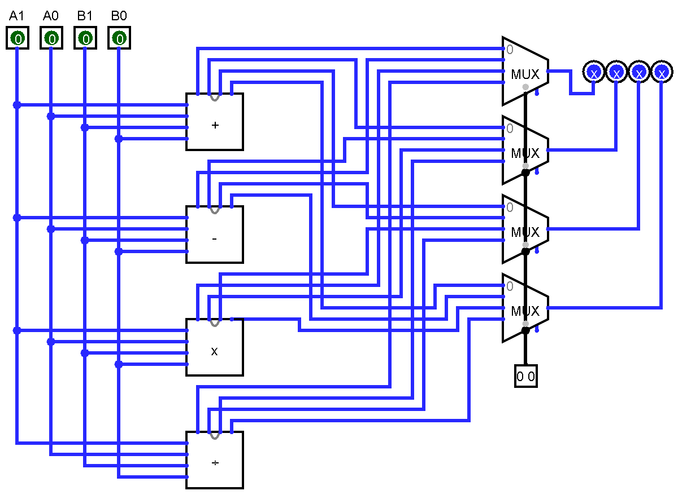

Figure combined circuit for all the operations

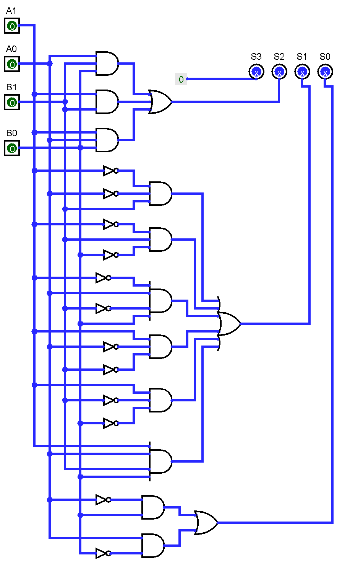

Figure adder circuit using basic gates

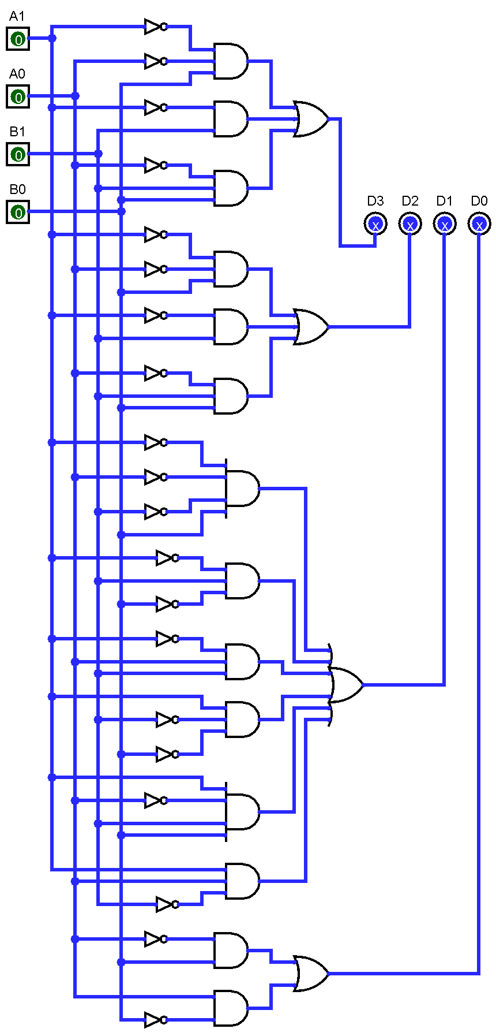

Figure subtraactor using basic gates

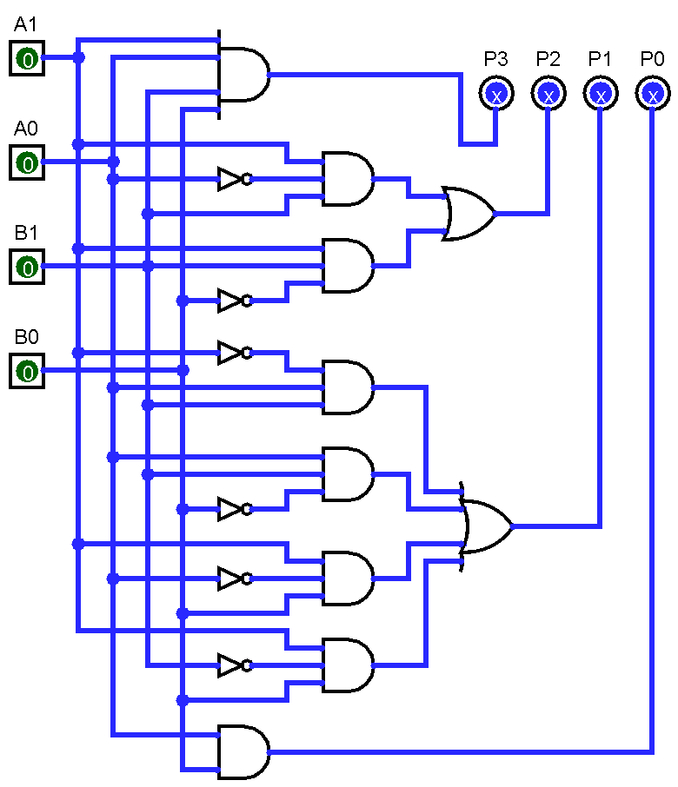

Figure multiplier using basic gates

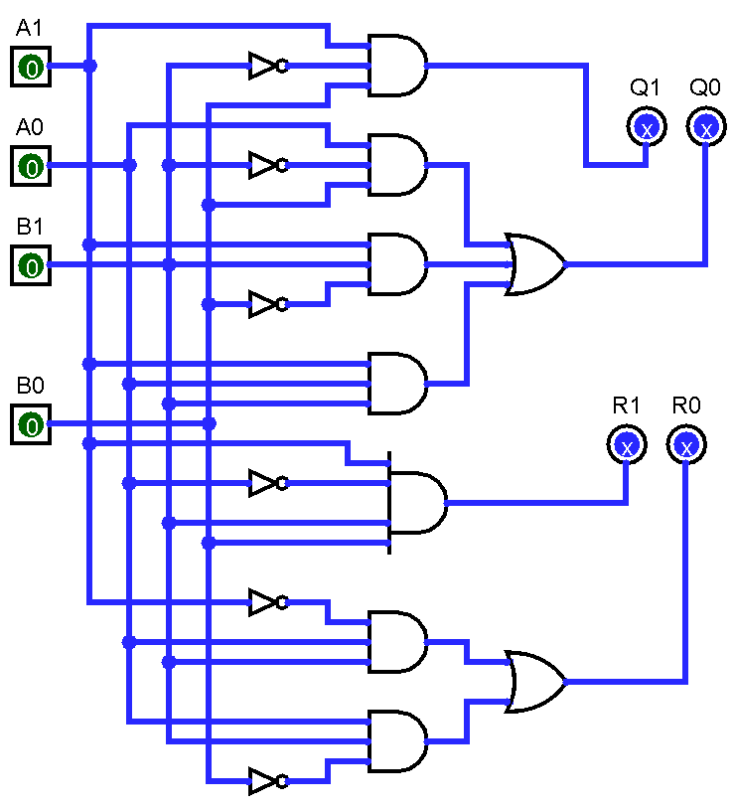

Figure divider using basic gates

## Simulation of the designed circuit

Adding $A= 01$ and $B= 11$, $S=00$ which is giving output $S = 0100$**.**

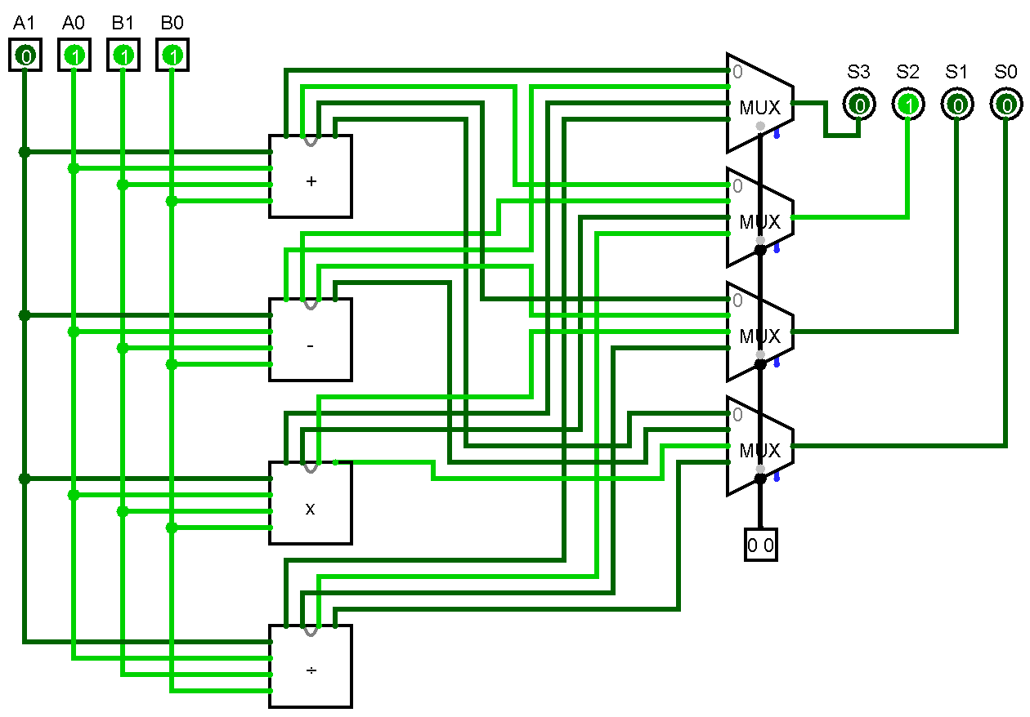

Figure simulation of adder (adding 1 and 3 )

Subtracting $A= 01$ and $B= 11$, $S=01$ which is giving output $S = 1110$**.**

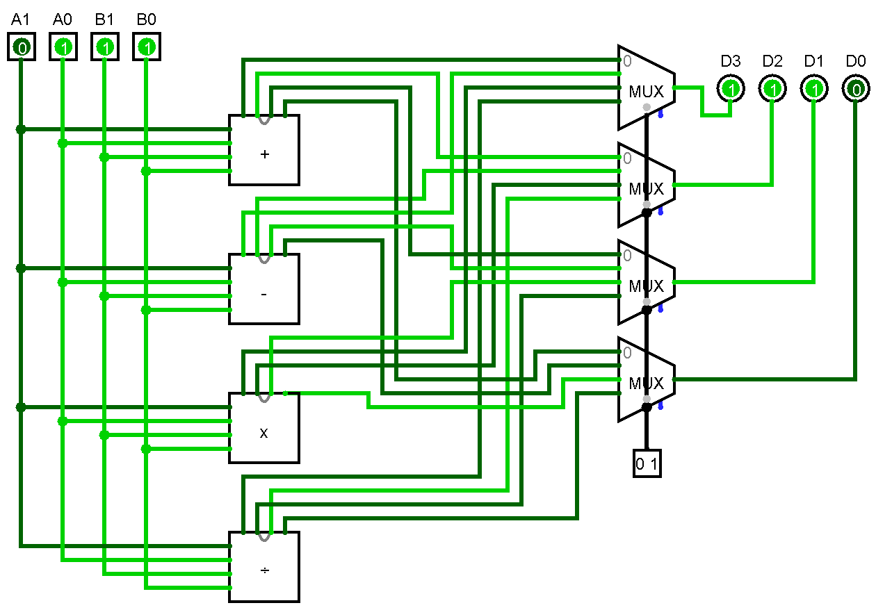

Figure simulation of subtractor (subtracting 1 and 3 )

Multiplying $A= 01$ and $B= 11$, $S=10$ which is giving output $S = 0011$**.**

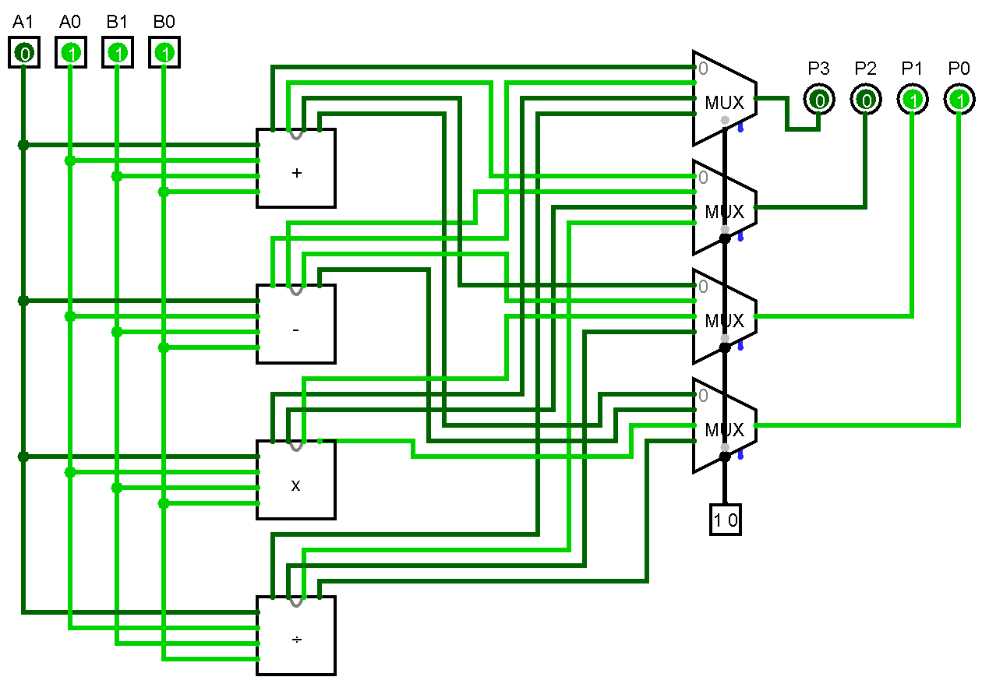

Figure simulation of multiplying (multiplying 1 and 3 )

Dividing $A= 01$ and $B= 11$, $S=11$ which is giving output $Q=00, R=01$**.**

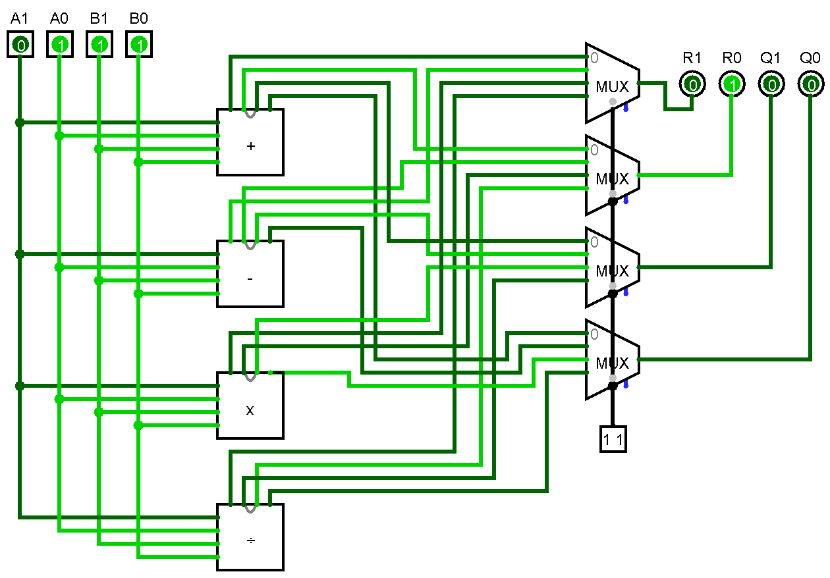

Figure simulation of divider (dividing 1 and 3 )

## 1.4 Changes in the circuit if you had to implement it using only NAND gates

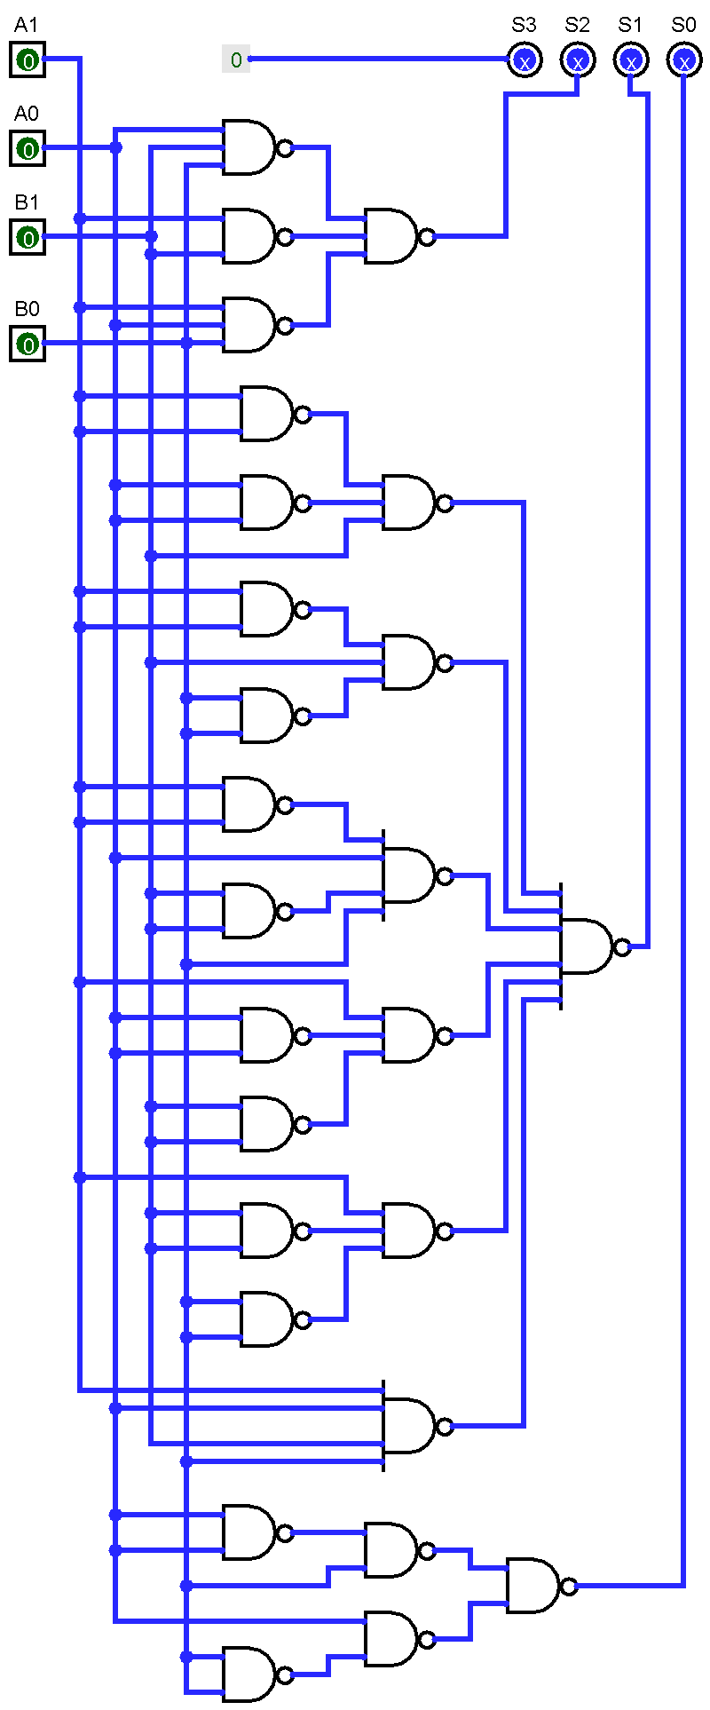

Figure adder circuit using NAND gates

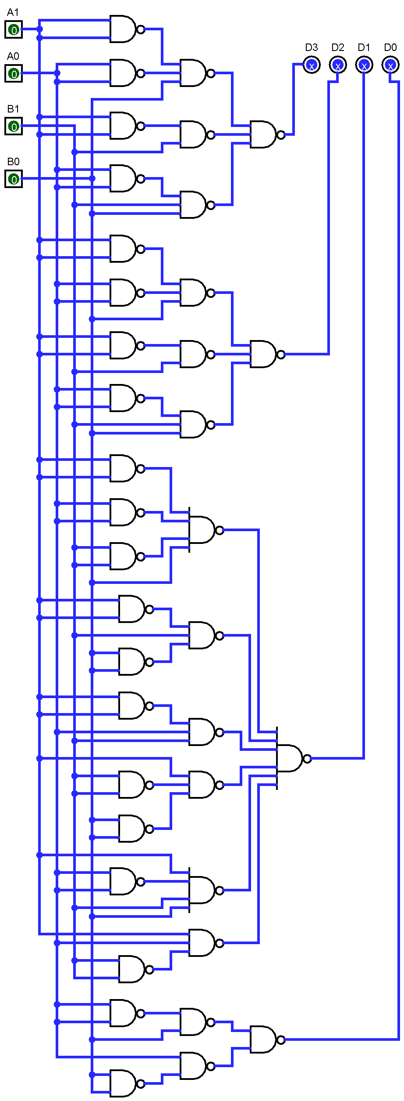

Figure subtractor circuit using NAND gates

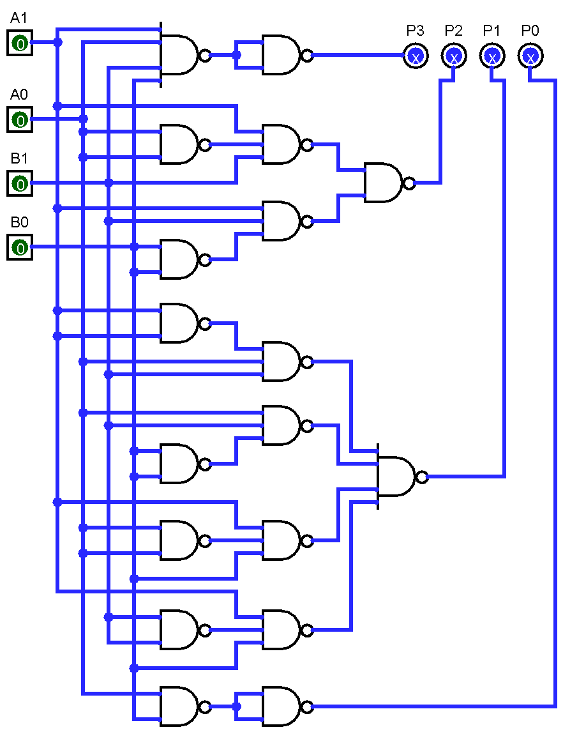

Figure multiplier circuit using NAND gates

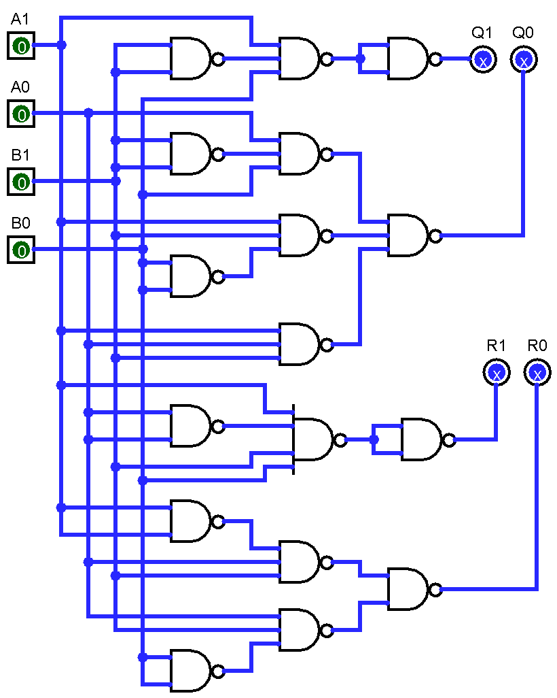

Figure divider circuit using NAND gates

# **Question No. 2**

**Solution to Question No. 2:**

## 2.1 Introduction to the functionality of the circuit

## This is a combinational circuit that generates 2’s complement of a 4-bit input binary number.

It takes $A (A3 A2 A1 A0)$ as input and gives $Y ( Y3 Y2 Y1 Y0$) which is 2’s complement of A as output.

Equations:

$Y3=\sim A0 \sim A1 \sim A2 A3 + A2 \sim A3 + A1 \sim A3 + A0 \sim A3$

$Y2=\sim A0 \sim A1 A2 + A1 \sim A2 + A0 \sim A2$

$Y1=\sim A0 A1 + A0 \sim A1$

$Y0=A0$

## 2.2 Circuit design using Logisim

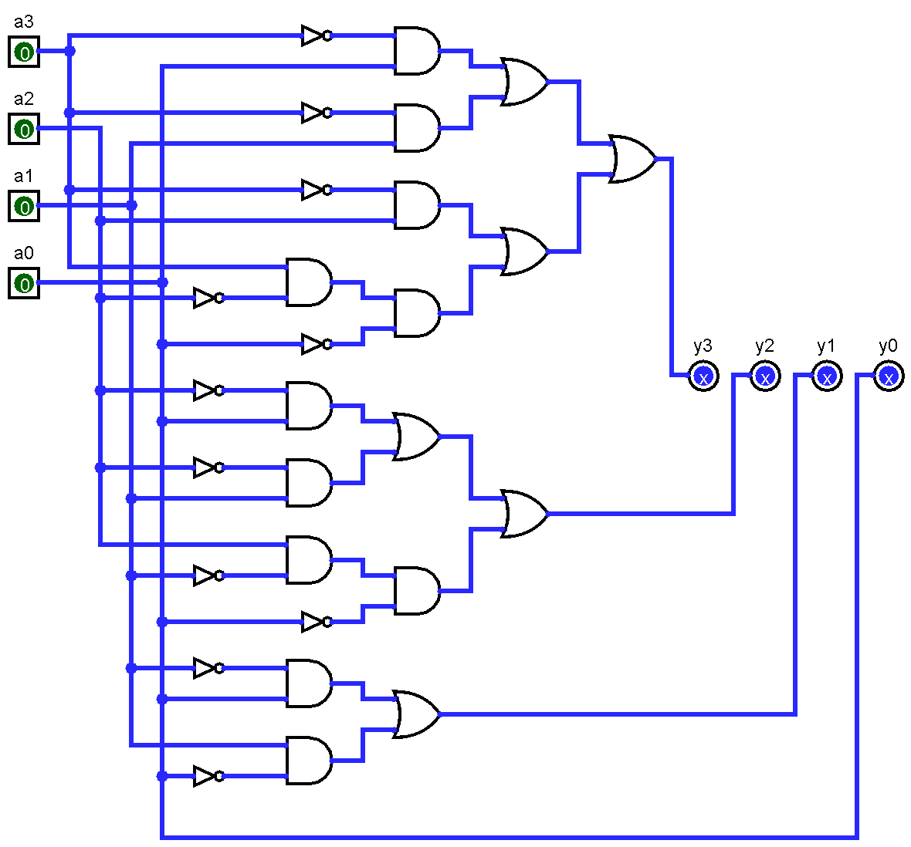

Figure 2’s complement calculator using basic gates

## 2.3 Simulation of the designed circuit

In Fig 15,

We can see for $A = 0110$ we are getting $Y= 1010$, which is the 2’s complement of A.

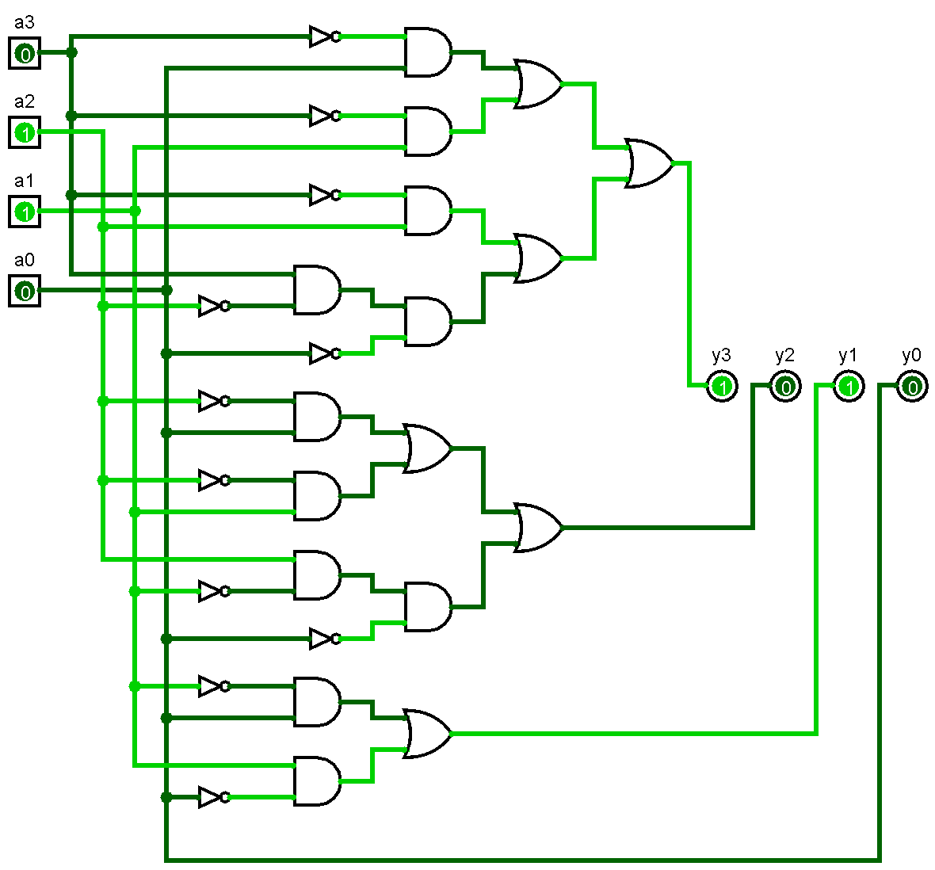

Figure simulating 2’s complement calculator

## 2.4 Changes in the circuit if you had to implement it using only XOR gates

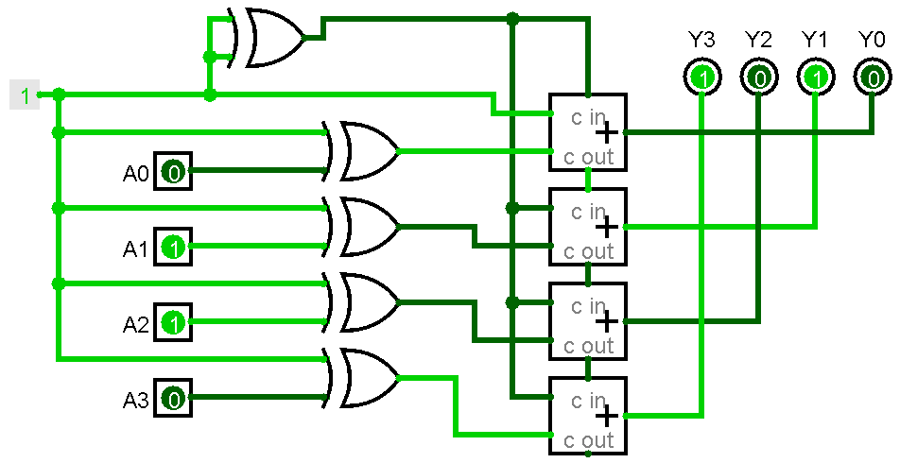

Figure 2’s complement calculator using XOR gate only.

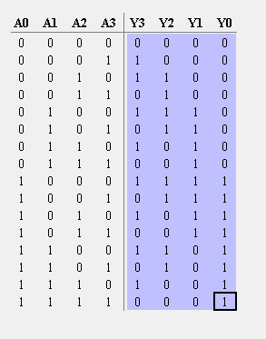

Figure truth table of 2's complement using XOR gate

# Bibliography

* Class notes / ppts
* <https://circuit-diagramz.com/circuit-diagram-calculator-using-logic-gates/>
* <https://rosettacode.org/wiki/Four_bit_adder>